Microsoft Teams Instructions & NILE ISS 5 RFI Industry Day Logistics
Setting Up Microsoft Teams
Microsoft Teams (MS Teams) can be set up either on your cell phone or computer. You can access MS Teams via a web browser or through the Teams desktop application on your computer. If you are using the web browser, we highly recommend you use Google Chrome browser. You can also download the MS Teams app on your phone.
*It is important to note that for official documents must not be downloaded off Teams onto your personal devices.*

Joining the Meeting
The NILE PMO will open the meeting 30 minutes beforehand at 05:30 PST / 14:30 CET on 10 November. This time will be used to ensure that all attendees are able to join the meeting successfully, and to facilitate a prompt start. There will not be any briefing material available during these 30-minute slots, nor will there be any question and answer available with the NILE PMO.
To join the Industry Day meeting, use either one of the two options outlined above – joining the meeting via the calendar tab or joining the meeting via link in the email invite.
If there are any issues joining the meeting, the NILE PMO has set up the following way to contact us to help troubleshoot:
- The PMO functional email account will be monitored the hour leading up to the meeting. Issues can be communicated to the NILE PMO via this account, at PMW_150_Nile_PMO@navy.mil
Please note that video will not be used during these events, in order to conserve bandwidth. Once joined, we ask that all attendees mute themselves to minimize the noise. The NILE PM will begin the meeting by welcoming participants to the Industry Day. Participants will then be invited to introduce themselves briefly.

When you join the events, you will see this view:
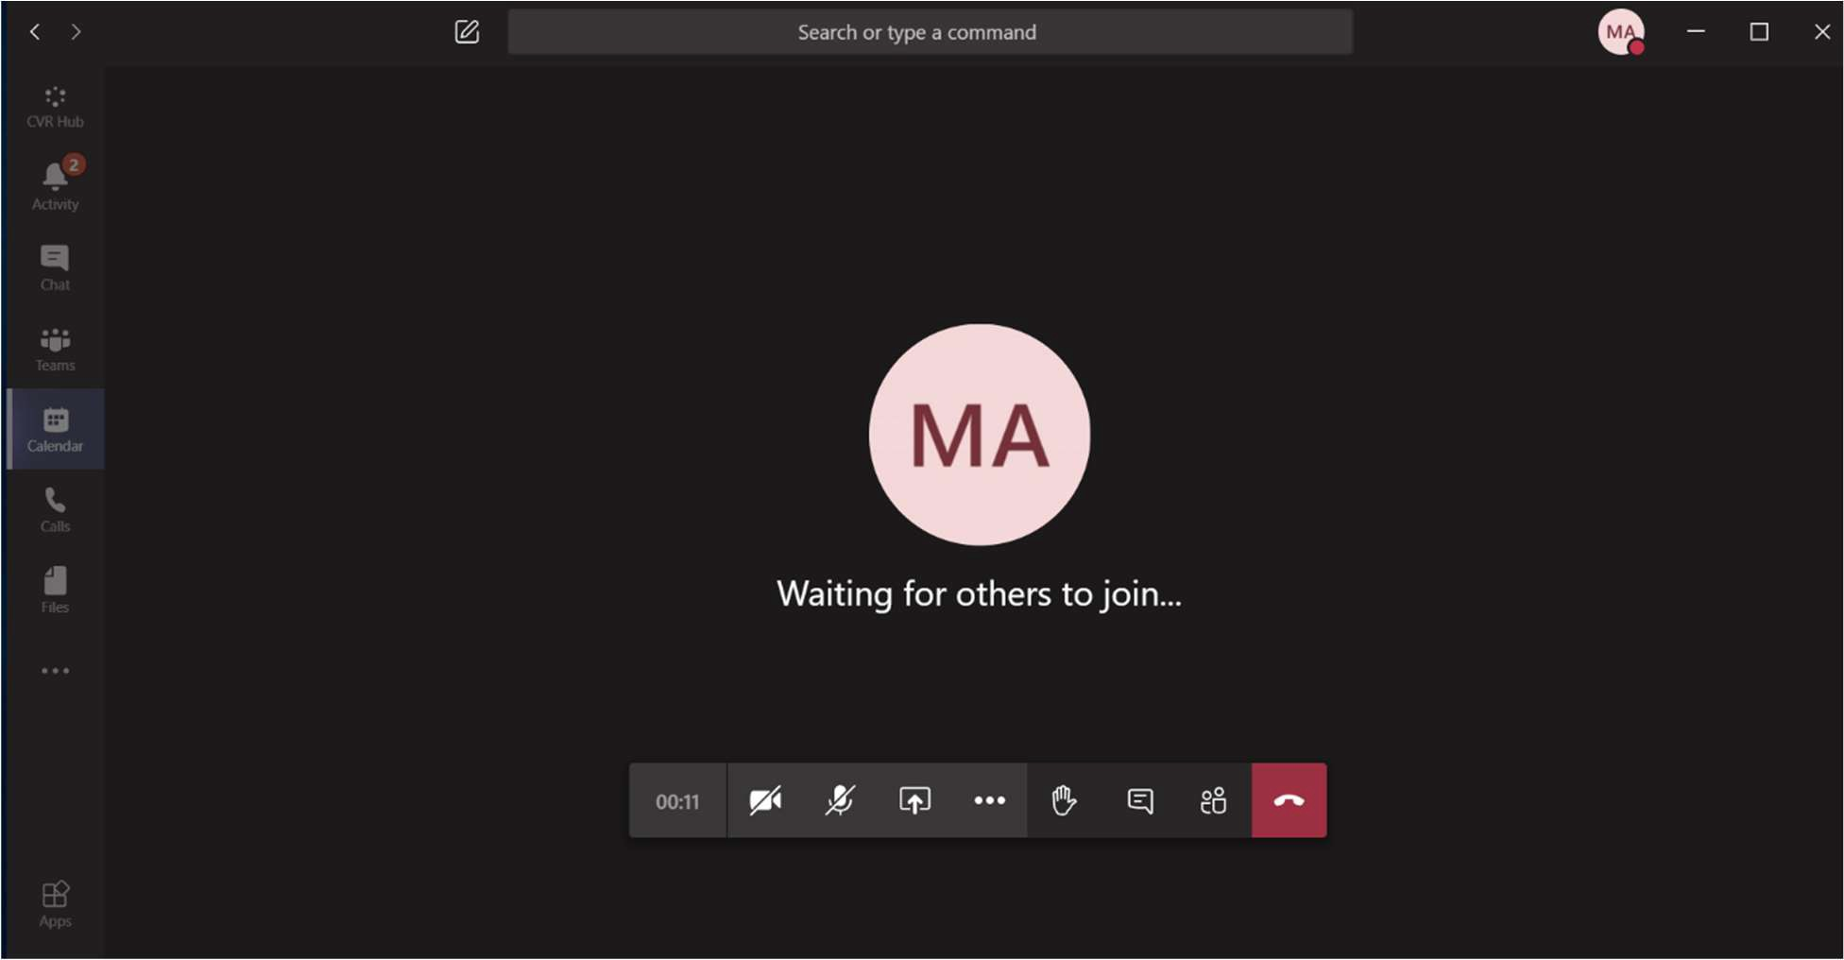

View of MS Teams using the desktop app

Tool display. From left to right: Timer, Camera (turned off), Mic (turned off), Share screens function, More options, Raise Hand, Chat, Participants, and end call.

Briefs
Ms. Aguilar will share her screen for all attendees to view the briefs.

Speakers
There will be four main speakers throughout the meeting: the NILE Project Manager, the UK Representative to the NILE PMO, the Italian Representative to the NILE PMO, and the NILE PMO Contract Specialist. Attendees are encouraged to ask questions and/or provide feedback. Refer to the following paragraph on the intended protocol for all questions.

Questions
Please hold all questions to the end of the appropriate brief. If you would like to ask a question, please use the “raise hand” function on MS Teams. The moderator will invite those who have raised their hand to ask their question verbally, by unmuting themselves. If you would like to refer to a specific slide, please state the slide number, and note that there is a slight delay when sharing screens. Either the presenter or the appropriate subject matter experts will answer the question.
Both events are being held at an unclassified level. Accordingly, we request that attendees consider the classification of any questions they ask, and the answers that they will entail. The Government will not be able to answer any questions of a classified nature, or that contravene the NILE ISS MoU A5.

Recording
The event will be recorded using MS Teams. This will allow the NILE PMO to distribute a transcript of all questions and answers from all three event on www.link22.org. The Government recommends the following:
- As the events are being recorded, all vendors must be on mute (other than when asking a question), so that no vendor proprietary information is inadvertently recorded by the Government or the vendor.
- Vendors may not modify any recording of the events.
- Vendors may not take excerpts from any recording and combine with another recording.
- Any future questions on the solicitation will be answered referencing the Government recording of the Industry Days as necessary. Vendor recordings may not be submitted as part of the question, and if submitted, will not be considered or referenced in the answer.

Meeting Summary

NILE ISS 5 RFI Industry Day – 10 November 2020
Agenda Item | Lead | Time (mins) | Start Time (CET) | End Time (CET)
Administrative Items | Ms Marissa Aguilar | 5 | 15:00 | 15:05
Opening Statement & Welcome | Mr Chuck Schwartz | 10 | 15:05 | 15:15
Participant Introductions | All | 10 | 15:15 | 15:25
NILE ISS 5 RFI Brief | Ms Amy Kilby | 30 | 15:25 | 15:55
NILE ISS 5 RFI Technical Brief | Capt Filippo Gandini | 20 | 15:55 | 16:15
NILE ISS 5 RFI Contract Brief | Mrs Mary Kopa | 15 | 16:15 | 16:30
Open Question & Answer Session | All | 30 | 16:30 | 17:00

Post-Meeting Actions
All questions and answers from both Industry Days will be transcribed from the recording, and a written record will be posted on www.link22.org and eCommerce.
If the volume of questions exceeds the schedule allotted for either of the Industry Days, attendees will be invited to submit additional questions by email and answers will be posted to www.link22.org and eCommerce.

